* Prva rýchla verzia racku by mohla byt tato, a v dohladnom case ked budete mat Visio k dispozicii (treba zistit ci ho mate v baliku Office365, alebo inak...) tak nakreslit aj druhy variant priamo so zariadeniami – t.j. predny a zadny pohlad na rack tak ako ho vidime, bud pouzit ikony s visia, alebo zobrat photo z webu.
* switche a routre by bolo vhodne ocislovat, idealne zlava doprava, rack 1, rack 2, rack 3 a zariadenia v nich: switch 1.1, 1.2, … 2.1, 2.2, ...router 1.1, 1.2.



### Provisioning Rack & HLR-FE Rack





### Power cabling

Tu by sme potrebovali nakreslit ako su zretazene predlzovacky dole v rackoch… vzdy vrchna zapina spodnu - 2 su vzdy zretazene, treba spocitat ktory konektor je ktore zariadenie a nejako to nakreslit nazorne. T.j. porty v predlzovacke ocislovat a napisat pre ake zariadenie je to (switch, router...) - switche a routre by bolo vhodne ocislovat, idealne zlava doprava, rack 1, rack 2, rack 3 a zariadenie v nich: switch 1.1, 1.2, router 1.1, 1.2..



# Room layout

## Prague CTX

Tu by sme potrebovali takyto layout aj s rozmermi miestnosti – idealne kreslit vo Visiu a zdrojovy document (visio) s nakresom dat zdielat na OneDrive tiez a aj tu vlozit obrazok.

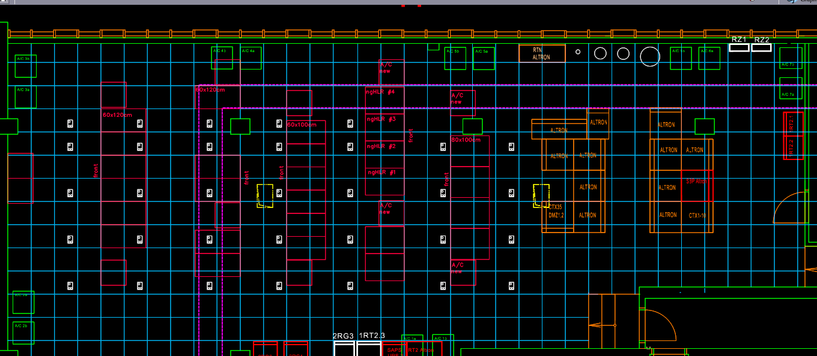

# Site Prague CTX

## HLRd Core Components... RB301 Rack 01

* Do popisu pre zariadenia:
  + Model zariadenia
  + Verzia IOSu
  + Pamäte
  + Procesor
  + Porty
  + Čo ešte iné?

|  |  |  |  |  |
| --- | --- | --- | --- | --- |
| **Hardware component** | | **Characteristics** | **Role** | **Quantity on site** |
|  | SUN Netra T2000 | -8xUltraSPARC64 CPU @ 1.2 GHz  -32GB DDR2 Ram  -2x146GB Disk capacity  -3 PCI-X, 1 PCI-E slots,  -4 onboard 10/100/1000 Ethernet ports  -1 Quad Gigabit Ethernet PCI card | Used as HLR Front End | **3** |
|  | Sun Netra v210 | -1xUltraSPARC Illi CPU @ 1.3 GHz  -1GB SDRAM  -1x73GB Disk capacity  -4 onboard 10/100/1000 Ethernet ports | Used as Install Server for HLR Front End | **1** |
| Ultimaco HSM | Utimaco SafeGuard Crypto Server CS10 | -Supports all commonly available symmetrical and asymmetrical cryptographic procedures and protocols  -Can generate up to 100 signatures per second | Hardware Security Module  (HSM) | **2** |
|  | FSC Primergy  RX600-S4 | -3xIntel Xeon Dual Core Processor (3.0 GHz, 667 MHz FSB)  -16GB Ram  -2x500GB Disk capacity  -2 10/100/1000 MBit/s Ethernet boards | Used as HLRd Database Front End | **2** |
| Used as Provisioning Gateway Directory Server Agent  (PGW-DSA) | **1** |
| Used as Provisioning Gateway (PGW) | **1** |
| -2xIntel Xeon Dual Core Processor (3.0 GHz, 667 MHz FSB)  -32GB Ram  -2x500GB Disk capacity  -2 10/100/1000 MBit/s Ethernet boards | Used for Database Management | **1** |
| Serves as HLRd Database Back End | **4** |
| Serves as Install Server for C-NTDB | **1** |
| Used as OneNDS DB Manager | **1** |
| PW 250 | FSC Primergy RX300 S3 | -2x Intel Xeoon dual core 1,6 GHz  -4GB Ram  -2X73 GB Disk capacity | Used as CITRIX Server for remote access | **1** |

## Network equipment (provided by TMCZ)

|  |  |  |  |  |
| --- | --- | --- | --- | --- |
| **Hardware component** | | **Characteristics** | **Role** | **Quantity on site** |
|  | Cisco Catalyst 2960G-24TC-L | - 24x1Gbps | Used as PGW Switch | **2** |
| Used as HSM Switch | **2** |
| CISCO Cat 4948 | Cisco Catalyst 4948-E | -48x1Gbps  -redundant fans  -redundant hot plug power supplies | Used as LAN Switch | **4** |
| asa5580 | Cisco ASA 5580 | - Two USB ports  - Two RJ-45 Management ports  - Two Gigabit Ethernet Management ports  With Interface Expansion Cards:  - Up to Twelve 10Gigabit Ethernet (10GE) ports  - Up to Twenty-Four Gigabit Ethernet ports  - Up to Twenty-Four 10/100/1000 Ethernet ports | Used as Firewall | **2** |
| Cisco Catalyst 6504-E Chassis | Cisco Catalyst 6506 | - Supervisor engines  - Fast Ethernet modules (with IEEE 802.3af Power over Ethernet [PoE])  - Gigabit Ethernet modules (with IEEE 802.3af PoE)  - 10 Gigabit Ethernet modules  - Flex WAN modules | Used as CE router | **2** |

## Additional components

|  |  |  |  |  |
| --- | --- | --- | --- | --- |
| **Hardware component** | | **Characteristics** | **Role** | **Quantity on site** |
| primecenter rack 38u | Primecenter Rack 38 RU | - 38U rack (H x W x D)  1825 x 700 x 1000 mm  Transport dimensions:  1935 x 775 x 1180 mm | Host all HLRd solution components | **4** |
| RC23 rack console | Primergy RC23  Rack console | -17-inch TFT flat screen display  -Connection for PS/2 and USB  -Telescopic rails with variable depth from 704 to 790 mm  -Integrated cable management  - German/International keyboard layout | Console of the HLRd Primecenter Racks | **4** |
| KVM console switches | Primepower Console Switches | -4/8 and 16 port switch  -End-to-end CAT5 connections  -GUI client for remote access  -Multi-platform switch | Console switch for HLRd Primecenter Racks | **4** |
| Rack_triton_Delta_S_1 | Triton DeltaS 800x900 rack : | - 45U rack  Dimensions (H x W x D)  2105 x 687 x 900 mm | Used to host network components  (Provided by TMCZ) | **2** |
| F5 BIG IP | Big IP F5  LTM-1500 | - high availability of IP applications/services running across multiple data centers  -local area application traffic management solution  - scalable SSL processing platform | Used for inter-connection and load-balancing between customer’s provisioning system and HLRd’s Provisioning Gateway (PGW) | **2** |

# Site Brno

|  |  |  |  |  |
| --- | --- | --- | --- | --- |
| **Hardware component** | | **Characteristics** | **Role** | **Quantity on site** |
|  | SUN Netra T2000 | -8xUltraSPARC64 CPU @ 1.2 GHz  -32GB DDR2 Ram  -2x146GB Disk capacity  -3 PCI-X, 1 PCI-E slots,  -4 onboard 10/100/1000 Ethernet ports  -1 Quad Gigabit Ethernet PCI card | Used as HLR Front End | **3** |
|  | Sun Netra v210 | -1xUltraSPARC Illi CPU @ 1.3 GHz  -1GB SDRAM  -1x73GB Disk capacity  -4 onboard 10/100/1000 Ethernet ports | Used as Install Server for HLR Front End | **1** |
| Ultimaco HSM | Utimaco SafeGuard Crypto Server CS10 | -Supports all commonly available symmetrical and asymmetrical cryptographic procedures and protocols  -Can generate up to 100 signatures per second | Hardware Security Module  (HSM) | **2** |
|  | FSC Primergy  RX600-S4 | -3xIntel Xeon Dual Core Processor (3.0 GHz, 667 MHz FSB)  -16GB Ram  -2x500GB Disk capacity  -2 10/100/1000 MBit/s Ethernet boards | Used as HLRd Database Front End | **2** |
| Used as Provisioning Gateway Directory Server Agent  (PGW-DSA) | **1** |
| Used as Provisioning Gateway (PGW) | **1** |
| -2xIntel Xeon Dual Core Processor (3.0 GHz, 667 MHz FSB)  -32GB Ram  -2x500GB Disk capacity  -2 10/100/1000 MBit/s Ethernet boards | Used for Database Management | **1** |
| Serves as HLRd Database Back End | **4** |
| Serves as Install Server for C-NTDB | **1** |
| Used as OneNDS DB Manager | **1** |

## HLRd Core Components

## Network equipment (provided by TMCZ)

|  |  |  |  |  |
| --- | --- | --- | --- | --- |
| **Hardware component** | | **Characteristics** | **Role** | **Quantity on site** |
|  | Cisco Catalyst 2960G-24TC-L | - 24x1Gbps | Used as PGW Switch | **2** |
| Used as HSM Switch | **2** |
| CISCO Cat 4948 | Cisco Catalyst 4948-E | -48x1Gbps  -redundant fans  -redundant hot plug power supplies | Used as LAN Switch | **4** |
| asa5580 | Cisco ASA 5580 | - Two USB ports  - Two RJ-45 Management ports  - Two Gigabit Ethernet Management ports  With Interface Expansion Cards:  - Up to Twelve 10Gigabit Ethernet (10GE) ports  - Up to Twenty-Four Gigabit Ethernet ports  - Up to Twenty-Four 10/100/1000 Ethernet ports | Used as Firewall | **2** |
| Cisco Catalyst 6504-E Chassis | Cisco Catalyst 6506 | - Supervisor engines  - Fast Ethernet modules (with IEEE 802.3af Power over Ethernet [PoE])  - Gigabit Ethernet modules (with IEEE 802.3af PoE)  - 10 Gigabit Ethernet modules  - Flex WAN modules | Used as CE router | **2** |

## Additional components

|  |  |  |  |  |
| --- | --- | --- | --- | --- |
| **Hardware component** | | **Characteristics** | **Role** | **Quantity on site** |
| primecenter rack 38u | Primecenter Rack 38 RU | - 38U rack (H x W x D)  1825 x 700 x 1000 mm  Transport dimensions:  1935 x 775 x 1180 mm | Host all HLRd solution components | **4** |
| RC23 rack console | Primergy RC23  Rack console | -17-inch TFT flat screen display  -Connection for PS/2 and USB  -Telescopic rails with variable depth from 704 to 790 mm  -Integrated cable management  - German/International keyboard layout | Console of the HLRd Primecenter Racks | **4** |
| KVM console switches | Primepower Console Switches | -4/8 and 16 port switch  -End-to-end CAT5 connections  -GUI client for remote access  -Multi-platform switch | Console switch for HLRd Primecenter Racks | **4** |
| Rack_triton_Delta_S_1 | Triton DeltaS 800x900 rack : | - 45U rack  Dimensions (H x W x D)  2105 x 687 x 900 mm | Used to host network components  (Provided by TMCZ) | **2** |